**Assignment: Creating Database for Lift Management System**

**Asgnmt Coordinator: Suresh Burde**

**Submitted By: Parth J. Bhosale**

**Class Diagram For the Lift Management System**

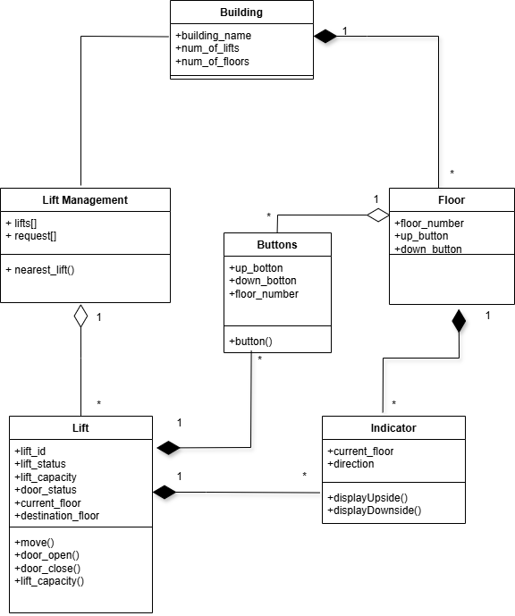

Entity Realtionship Diagram

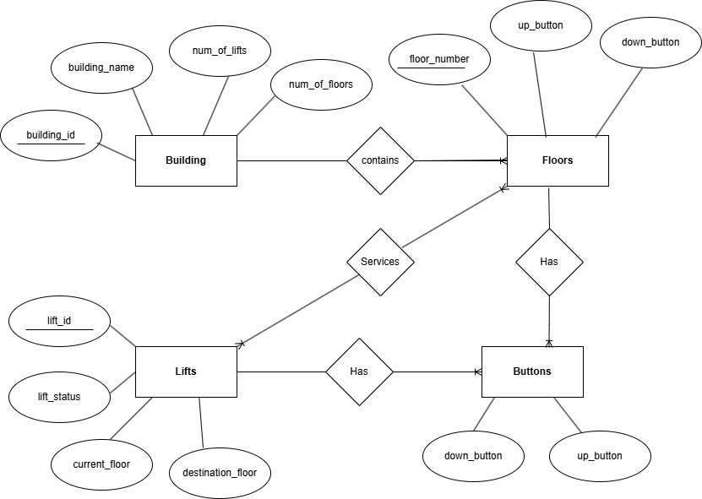

**Database :** MySQL

**Tables count :** 6

**Tables :** Building, buttons, floor, lift_management, lift and indicator.

#Creating lift_management_system database

Query : CREATE DATABASE lift_management_system;

#Show databases

Query: SHOW DATABASES;

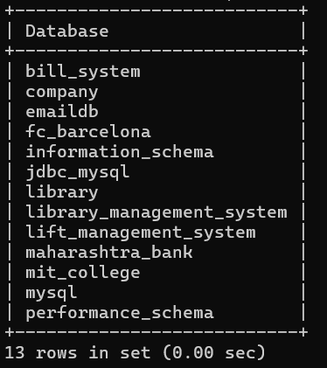

#Use lift management system database

Query: USE lift_management_system;

#Create building table.

Query : CREATE TABLE Building(building_id INT AUTO_INCREMENT PRIMARY KEY, building_name VARCHAR(255) NOT NULL, num_of_lifts INT NOT NULL , num_of_floors INT NOT NULL );

#Description of building table.

Query : DESC building;

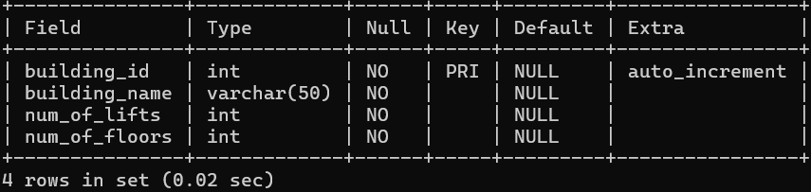

#Inserting Values

INSERT INTO building VALUES

(null, ‘Amanora’, 10, 40),

(null, ‘Avenue 69’, 20,60),

(null, ‘Twin Tower’, 20, 90),

(null, ‘White House’, 6, 20),

(null, ‘Matti’, 5, 20);

#View

SELECT * FROM building;

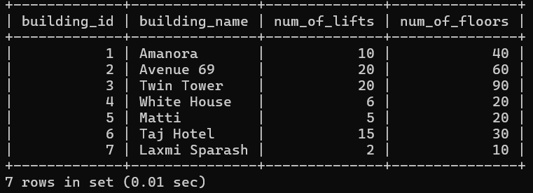

#Updating building table

Query : UPDATE building SET num_of_lifts = 15 WHERE building_id = 1;



#Creating lift management table

CREATE TABLE lift_management ( ID INT AUTO_INCREMENT PRIMARY KEY, NUMBER_OF_LIFTS INT NOT NULL, REPORT_DATE TIMESTAMP DEFAULT CURRENT_TIMESTAMP );

#Description of lift management table

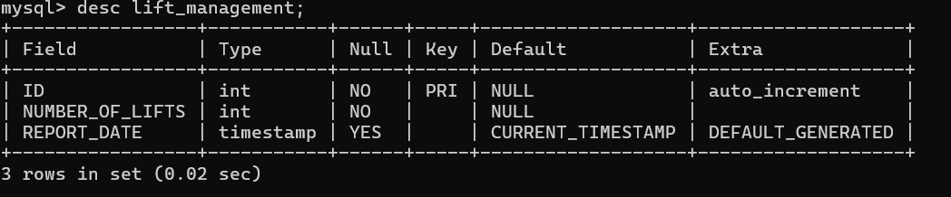

#View

#Select query

#Query : SELECT * FROM LIFT_MANAGEMENT WHERE ID=2;

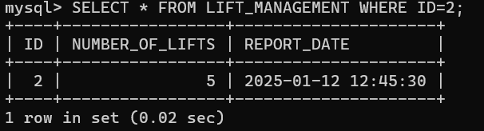

#Creating floor Table

Query : CREATE TABLE floor(floor_id INT AUTO_INCREMENT PRIMARY KEY, up_button VARCHAR(50) NOT NULL, down_button VARCHAR(50) NOT NULL);

Query: INSERT INTO FLOOR VALUES(NULL,TRUE,FALSE),(NULL,TRUE,FALSE),(NULL,FALSE,TRUE),(NULL,TRUE,TRUE),(NULL,TRUE,TRUE),(NULL,FALSE,FALSE);

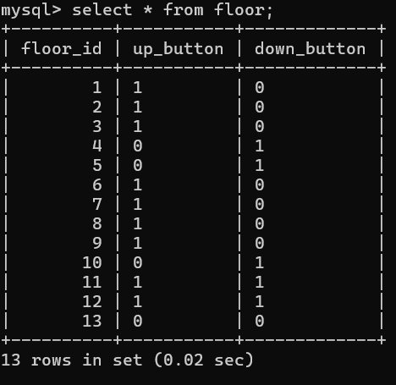

#Creating Lift Table

Query : CREATE TABLE LIFT(LIFT_ID INT AUTO_INCREMENT PRIMARY KEY, LIFT_STATUS VARCHAR(50) NOT NULL, LIFT_CAPACITY INT NOT NULL, DOOR_STATUS VARCHAR(50) NOT NULL, CURRENT_FLOOR INT NOT NULL, DESTINATION_FLOOR INT NOT NULL);

#Description of lift Table

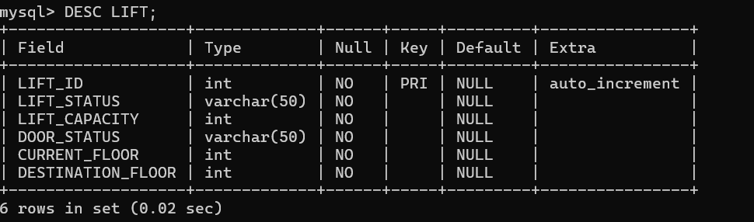

INSERT INTO LIFT VALUES

(NULL, "IDLE",400,"OPEN",2,23),

(NULL, "MOVING",450,"CLOSE",21,26),

(NULL, "MOVING",400,"CLOSE",12,3),

(NULL, "MOVING",400,"CLOSE",2,17);

**#**Selecting maximum destination lift:

#Query : SELECT * FROM LIFT WHERE DESTINATION_FLOOR = (SELECT MAX(DESTINATION_FLOOR) FROM LIFT);

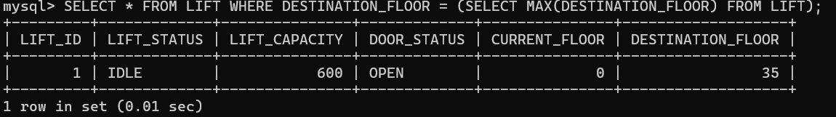

#Moving lifts:

#Query : SELECT * FROM LIFT WHERE LIFT_STATUS="MOVING";

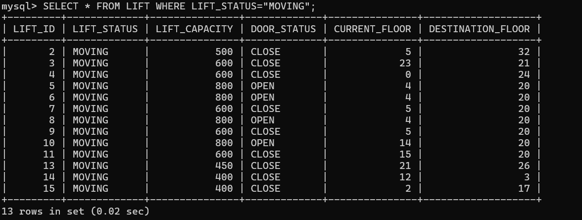

#Total number of lifts

#Query : SELECT COUNT(*) AS TOTAL_LIFTS FROM LIFT;

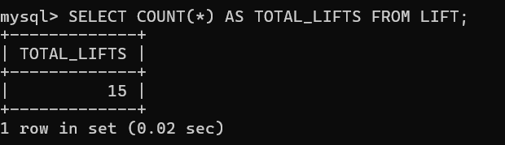

#Creating buttons table

#Query :

CREATE TABLE buttons(ID INT AUTO_INCREMENT PRIMARY KEY, UP_BUTTON VARCHAR(50) NOT NULL, DOWN_BUTTON VARCHAR(50) NOT NULL);

#Description of buttons table :

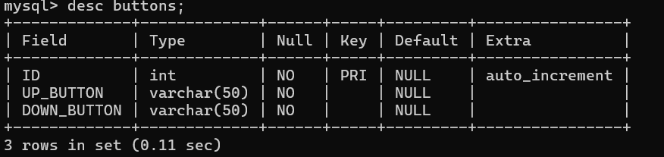

#View :

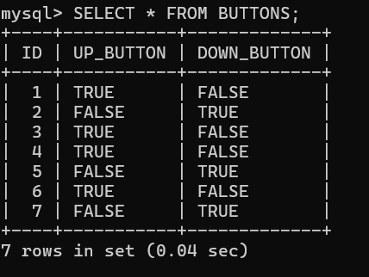

#Indicator table :

